Homework 1 – Smart Parking Platform
By: Riyan Momin
1: Analysis:
There are some parking apps and websites already, that can show you where open parking is, pay for the parking, and reserve specific parking spots also. There are 4 examples which I looked into, which are ParkMobile, Spothero, PaybyPhone, and Passport parking. Every app has its own advantages, and dis-advantages as well.
ParkMobile is good to find and reserve open parking spots and pay for it through your phone also. It would show you open parking spots and you can reserve that spot directly from your phone, which is very convenient.
Spothero: For events and airport parking, you can reserve it in advance, and pay for it for how ever long you want the parking spot for. This app also makes it easy to reserve the parking location directly through your phone. Although, this app doesn’t completely show which parking spots are filled or not, so you kind of have to take time to search for open ones and correct one where your car can fit.
PaybyPhone: This app is convenient for parking alerts, if anything is going on and you’ve parked there and put it in the system, you would receive notifications regarding any alerts or dangers or anything. This app isn’t the best for cities which don’t have a lot of parking options since it might be out-dated.
Passport parking: This app is very good for simple users, since the payment is easy to do, and you also get parking information and alerts.
2: Draft of Vision and Scope:
For this semester project, we are the company $oftware corp, which has unlimited resources and a unlimited budget. This company has been chosen to manage and plan the development of a smart parking platform, which includes a website and mobile apps also. The main goal is to create an app and website where drivers can easily find, pay for, and reserve parking spots.
The vision is to make parking easier for drivers, and also for the parking lot management for better options on how to manage their parking lot easier. There should be like an admin side, which would be for the parking lot management, and then a user side, which the drivers would use to find parking easily.

The system would have the following features.:
Website and Mobile app
Admin login per parking lot management
Admin dashboard of what cars are parked where and for how long
User signup
Real time update for the parking lot
Up-to-date parking lot map
Digital payment from phone app or website
Reservation for parking
Parking lot measurement if a truck or big car can fit or not
Receipts sent to phone number or email
History of where you have parked before
Important alerts and notifications
End of the day, week and month analytics for admin and both user
Stakeholders:
Drivers and car owners
Parking lot management and owners
System admins
Website and mobile app users
Payment providers
Billing side
Website and app development team

3: SRS Draft 15 use cases:
The following use cases is the first draft, which show how the app and website will work for both the user, and admins, and how they can use it easily and save time also.
1: The driver/user creates an account and enters their required account information, like name, email and phone number.
2: The driver/user logs in and the online system verifies that everything is updated and stored in the database.
3: The driver/user can search for parking and the system will start searching.
4: The system will then show the driver/user which spaces are open.
5: The app/website will show the exact parking spots open in the map
6: If the driver/user clicks on exact parking spot then it will show the driver/user the information about the parking spot, like the number, and pricing.
7: The driver/user can then reserve a parking spot and choose for how long they want to reserve it, and wait for the payment screen.
8: This is where the payment provider will come in. The driver/user will have to pay for their selected spot, and wait a few seconds to make sure it’s confirmed and paid for.
9: When confirmed, the driver/user will be shown the directions to their exact parking spot.
10: The driver/user will receive information alerts and notification about the drivers specific parking spot, and the parking lot also for safety.
11: The driver/user can view their receipt which would be saved on the app, as well as either sent to their phone number or email, this depends on what option the user chooses.
12: The driver/user can then view their account history, where they have parked, for how long, and how much they paid also.
13: The parking management will log into their admin side user to view information.
14: The admin side will show how many parking spots are open and how many are filled.
15: The parking lot management will see the parking data, how many cars have been in and out of the parking lot, for how long a specific car was parked at a specific spot, and the option for rates also.

4: The differences between other apps and ours
The main difference between the other apps and ours would be that everything is on one platform, making it easy for users and the admin also. The driver/user can search for parking, see which spots are open, reserve it for a specific time, and then pay for it and see the directions on their phone for the parking lot, and then get confirmation receipt also. The admin side for the parking lot management will have a dashboard showing how many spots are filled and how many are open, what cars have been in and out, and the rates also.
5: Conclusion
This first homework is just the start for the semester project. As stated from before, there are multiple apps for parking, so our apps needs to be much better and user friendly for people and companies to actually switch over to our app. Moving further down the road, updates will be made and more features would be coming out in the future.

Homework 2 – WBS and timeline for Smart Parking Platform
The work for this week is to break down the structure of the website and the application, so we can have the database good to go, and the key features pointed out and ready to develop. This week will improve the development and put the ideas into use and how they will actually be imbedded into the application from all the ideas and thoughts from week 1.
- Smart Parking Platform
  - Frontend Website
1.1.2 Main homepage and the map view
1.1.3 Parking reversation and payment
1.1.4 User account dashboard and other features
1.2 Mobile Applications
1.2.1 iOS Application
1.2.2 Android Application
1.2.3 Login access
1.2.4 Notifications and alerts
1.3 API services and backend
1.3.1 Secure registration
1.3.2 Secure Login
1.3.3 Separate users
1.3.4 Admins and regular users signup
1.4 Reservation and parking engines
1.4.1 Real time map
1.4.2 Updates of the parking spots in real time
1.4.3 Booking engine
1.4.4 Reservation engine
1.5 Payment Processing
1.5.1 Third party payment services
1.5.2 Build payment into application and website
1.5.3 Receipts
1.5.4 Billing history
1.6 Location Services
1.6.1 Interactive Map
1.6.2 Real time live map
1.6.3 Vehicle size and fitment per spot
1.6.4 Directions using map to the parking spot which is reserved by user
1.7 Admin Dashboard
1.7.1 End of the day/week/ and month reports and analytics
1.7.2 Pricing management
1.7.3 Add remove and edit admins and users
1.7.4 Add remove and edit parking spots
1.8 Testing
1.8.1 Integration testing
1.8.2 Users and admins stay separate testing
1.8.3 No bugs or glitches testing
1.8.4 Security testing for both users and admins
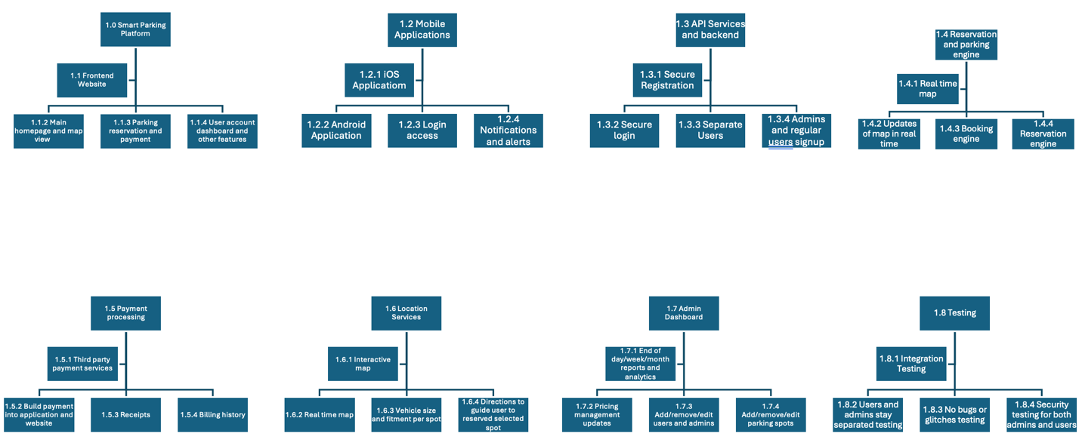
Grantt Chart
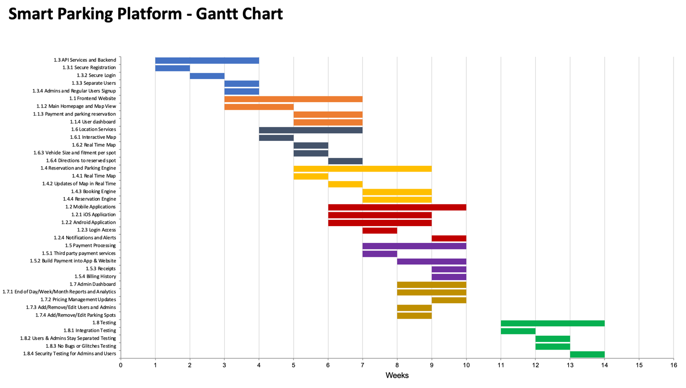

The main milestones for week 2 is that the main backend, website, application and mapping is integrated into a working draft.

Homework 3: Backlog and Sprint 1 Plan
The work for this week is to create a backlog system using Homework 1 features, and the breakdown structure from Homework 2. The 1st sprint creates accounts, separation between users and roles, the data, and splash screens, and then later on, additional features will be added.
Login 5 Items
- Create user/driver account with name, email, phone number and password
- Create admin account for the management of the parking management
- Sign in using the email and password
- Have a recovery password email sent through secure email
- Automatically sign out and expire the session due to inactivity

User and Operator interface
- User/driver screen with nearby parking and searching engine
- Search results show up that are nearby, if it’s available, and the pricing
- Real-time useable map with open parking spots shown
- Parking details with real-time rates per hour, and parking size limits also
- Space detail view
- Vehicle profile with car type, and license plate number
- Time selection and reversation details
- Confirmation screen and reservation timing
- Payment status and checkout screen
- Directions to parking garage, and selected reserved spot
- Driver homescreen dashboard and reserved spot
- Receipt viewer and reservation history
- User/driver notifications and alerts through app, text, and email
- Operator/admin dashboard with taken and open spots
- Operator/admin map with space status, and what cars are parked where with payment status and vehicle information
Backend process for User and Operator
- Store driver/user and operator/admin accounts securely and safely
- Have role permissions for user/driver and operator.admin
- Fix issues with revoked authenticated sessions
- Maintain management, spaces, spots, and pricing
- Have parking space occupancy updates every 15 minutes
- Publish real-time search and maps
- Filter spaces using the vehicle information which user/driver inputted
- Check avaible spots when reservation is requested
- Hold/lock a spot for 5-10 minutes while checking out
- Create and expire reservations during the selected times
- Automatically calculate the pricing rate depending on the duration of the stay
- Send payment request
- Create receipt and put it into the user/driver account history
- Send reservation confirmation and time alerts before expiration
- Record and keep the occupancy and pricing changes
Reporting for User and Operator
- User/driver report of parking session by selected date
- User/driver report of spending
- User/driver history of receipts and payments
- User/driver of commonly used parking garages
- User/driver report of overstayed and canceled reservations
- Operator/admin daily report of parking spots
- Operator/admin weekly occupancy trend
- Operator/admin monthly total overview reports
- Operator/admin revenue report by parking garage and selected dates
- Operator/admin of bookings, cancellations, parking rates, average duration, and total reports
Trello Board:
